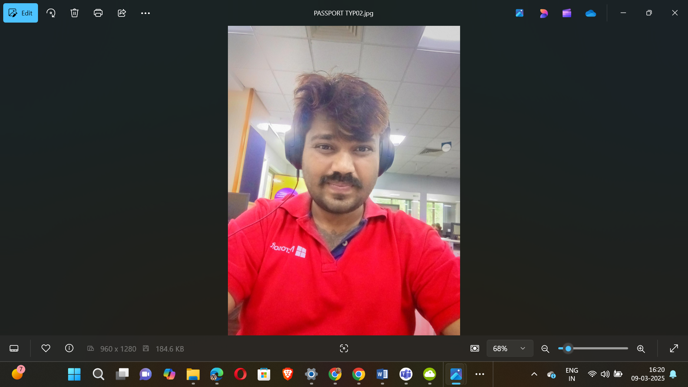

|  |  |
| --- | --- |
|  |  |

🕉️🏇🪓🪈🏹👑👑👑👑👑🤴🦁💿✈️🛸🚀🪩🥏🍥🕺

18+1 JAYA KURUKSHETRA MAHABHARAT SERIES

531

537

541

543

547

551

553

557

559

561

567

571

573

579

583

589

591

593

597

🕺🍥🥏🪩🚀🛸✈️💿🦁🤴👑👑👑👑👑🏹🪈💝🏇🪓🕉️

🕉️🏇🪓🪈🏹👑👑👑👑👑🤴🦁💿✈️🛸🚀🪩🥏🍥🕺

100 – PLATINUM JUBILEE

75 – DIAMOND JUBILEE

50 - GOLDEN JUBILEE

25 – SILVER JUBILEE

Apply 4 x 19 = 76

5

10 – 5 X 2

20 – 5 X 4

40 – 5 X 8

80 – 5 X 16

Apply 5 x 19 = 95

Total 95+76=171 kalalu

SUPREME MAGICAL ✨ SPACE THEATRE PROGRAMMING SHOWSS

🕺🍥🥏🪩🚀🛸✈️💿🦁🤴👑👑👑👑👑🏹🪈💝🏇🪓🕉️



|  |  |  |
| --- | --- | --- |
| S.NO | SLIDESHARE LINK | GITHUB URL |
| MODULE1 | [S1](https://www.slideshare.net/slideshow/space-programming-series-set-i-docx/276216119) | [G1](https://github.com/KVBharatBhushan/-MODULE1-SPACE-PROGRAMMING-SERIES-) |
| MODULE2 | [S2](https://www.slideshare.net/slideshow/space-programming-series-set-ii-docx/276216368) | [G2](https://github.com/KVBharatBhushan/-MODULE2-SPACE-PROGRAMMING-SERIES-) |
| MODULE3 | [S3](https://www.slideshare.net/slideshow/space-programming-series-set-iii-docx/276216404) | [G3](https://github.com/KVBharatBhushan/-MODULE3-SPACE-PROGRAMMING-SERIES-) |
| MODULE4 | [S4](https://www.slideshare.net/slideshow/space-programming-series-set-iv-docx/276216454) | [G4](https://github.com/KVBharatBhushan/-MODULE4-SPACE-PROGRAMMING-SERIES-) |
| MODULE5 | [S5](https://www.slideshare.net/slideshow/space-programming-series-set-v-docx/276216541) | [G5](https://github.com/KVBharatBhushan/-MODULE5-SPACE-PROGRAMMING-SERIES-) |
| MODULE6 | [S6](https://www.slideshare.net/slideshow/space-programming-series-set-vi-docx/276216577) | [G6](https://github.com/KVBharatBhushan/-MODULE6-SPACE-PROGRAMMING-SERIES-) |
| MODULE7 | [S7](https://www.slideshare.net/slideshow/space-programming-series-set-vii-docx/276216653) | [G7](https://github.com/KVBharatBhushan/-MODULE7-SPACE-PROGRAMMING-SERIES-) |
| MODULE8 | [S8](https://www.slideshare.net/slideshow/space-programming-series-set-viii-docx/276216711) | [G8](https://github.com/KVBharatBhushan/-MODULE8-SPACE-PROGRAMMING-SERIES-) |
| MODULE9 | [S9](https://www.slideshare.net/slideshow/space-programming-series-set-ix-docx/276216814) | [G9](https://github.com/KVBharatBhushan/-MODULE9-SPACE-PROGRAMMING-SERIES-) |
| MODULE10 | [S10](https://www.slideshare.net/slideshow/space-programming-series-set-x-docx/276260090) | [G10](https://github.com/KVBharatBhushan/-MODULE10-SPACE-PROGRAMMING-SERIES-) |
| MODULE11 | [S11](https://www.slideshare.net/slideshow/space-programming-series-set-xi-docx/276260205) | [G11](https://github.com/KVBharatBhushan/-MODULE11-SPACE-PROGRAMMING-SERIES-) |
| MODULE12 | [S12](https://www.slideshare.net/slideshow/space-programming-series-set-xii-docx/276260296) | [G12](https://github.com/KVBharatBhushan/-MODULE12-SPACE-PROGRAMMING-SERIES-) |
| MODULE13 | [S13](https://www.slideshare.net/slideshow/space-programming-series-set-xiii-docx/276260464) | [G13](https://github.com/KVBharatBhushan/-MODULE13-SPACE-PROGRAMMING-SERIES-) |
| MODULE14 | [S14](https://www.slideshare.net/slideshow/space-programming-series-set-xiv-docx/276260572) | [G14](https://github.com/KVBharatBhushan/-MODULE14-SPACE-PROGRAMMING-SERIES-) |
| MODULE15 | [S15](https://www.slideshare.net/slideshow/space-programming-series-set-xv-docx/276260636) | [G15](https://github.com/KVBharatBhushan/-MODULE15-SPACE-PROGRAMMING-SERIES-) |
| MODULE16 | [S16](https://www.slideshare.net/slideshow/space-programming-series-set-xvi-docx/276260764) | [G16](https://github.com/KVBharatBhushan/-MODULE16-SPACE-PROGRAMMING-SERIES-) |
| MODULE17 | [S17](https://www.slideshare.net/slideshow/space-programming-series-set-xvii-docx/276260920) | [G17](https://github.com/KVBharatBhushan/-MODULE17-SPACE-PROGRAMMING-SERIES-) |
| MODULE18 | [S18](https://www.slideshare.net/slideshow/space-programming-series-set-xviii-docx/276261016) | [G18](https://github.com/KVBharatBhushan/-MODULE18-SPACE-PROGRAMMING-SERIES-) |
| MODULE19 | [S19](https://www.slideshare.net/slideshow/space-programming-series-set-xix-docx/276282053) | [G19](https://github.com/KVBharatBhushan/-MODULE19-SPACE-PROGRAMMING-SERIES-) |
| MODULE20 | [S20](https://www.slideshare.net/slideshow/space-programming-series-set-xx-docx/276301852) | [G20](https://github.com/KVBharatBhushan/-MODULE20-SPACE-PROGRAMMING-SERIES-) |



🕉️🏇🪓🪈🏹👑👑👑👑👑🤴🦁💿✈️🛸🚀🪩🥏🍥🕺

|  |  |
| --- | --- |
| Personal Details | |
| Email Ids | **KINGVISHNUBHARATBHUSHAN@GMAIL.COM,**  **kvbharatbhushan@hotmail.com,** [**kvbharatbhushan1508@gmail.com**](mailto:kvbharatbhushan1508@gmail.com)**,**  [**thejuniorgod@gmail.com**](mailto:thejuniorgod@gmail.com)**,**  **KINGVISHNUBHARATBHUSHAN@HOTMAIL.COM** |
| Skype Personal | **thejuniorgod** |
| My MS Teams | **kvbharatbhushan@hotmail.com** |
| LinkedIn | <https://www.linkedin.com/in/major-kalkikingkongkvkalkikingalmightyalfa1-a-795646b6> |
| My Instagram | <https://www.instagram.com/majorkalkikingkongkvkalkikinga> |
| My C# Corner | <https://www.c-sharpcorner.com/members/junior-god> |
| My Twitter | https://x.com/The_Junior_God |
| My GitHub | <https://github.com/KVBharatBhushan> |
| My SlideShare | <https://www.slideshare.net/TheJuniorGod> |
| My FB Account | <https://www.facebook.com/kaveri.bhushan> |
| My FB International Page | <https://www.facebook.com/profile.php?id=100076450444292> |
| Mobile Number | **+91-9121780098,+91-7058272379** |
| PAN Number | **BBOPK0120M** |
| Passport Number | **J2280303, Z6157606** |



